R.VINOD REDDY, Advocate

Standing Counsel for TSTRANSCO/TSSPDCL

H.No.8-2-684/4/31, Plot No.26, Anand Banjara,

Road No.12, Banjara Hills, Hyderabad – 500034

Ph: 040-23304342
9849041514

Advance Receipt

Date: 11-02-2021

Received a sum of Rs.12000/- (Rupees Twelve thousand only) as per latest SP. O. O Js(IR & M) Ms. No. 24 dated 08-01-2018 from Superintending Engineer, Operations, Hyderabad South, TSSPDCL towards filing Vacate Stay Petition and Counter Affidavit in WP. No. 845 of 2021 filed by Hridainath Asoorya before Hon’ble High Court at Hyderabad.

1) Legal Fee : Rs. 5000 =00
2) Filling Expenses : Rs. 5000=00
3) Vacate Stay Petition : Rs. 2000=00

Total : Rs. 12000=00

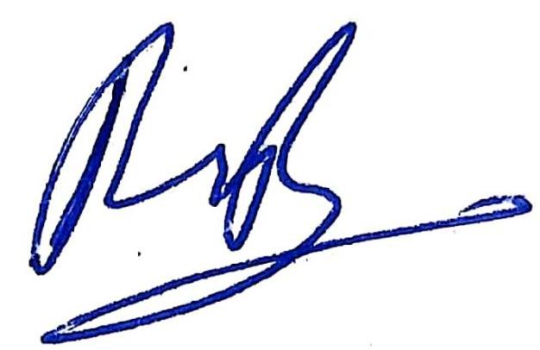
(R.Vinod Reddy)

